**Is Age of Empires 2: DE Unbalanced?**

A closer examination into the one-on-one win rate statistics based on faction choice.

By: Alexander Mortillite

Contents

Overview 3

Background 3

Goals 3

Additional Information 3

Problems 4

Questions From Chapter 1: 4

Questions From Chapter 2: 6

Questions from Chapter 3: 8

Findings and Conclusions: 9

Disclaimer 9

Final Thoughts 9

# **Overview**

## **Background**

* Age of Empires 2: Definitive Edition is the remastered version of one of the most popular real time strategy games of all time. Originally debuting in 1999 Age of empires 2: The Age of Kings, quickly became praised for its historical flavor, introducing many new civilizations to the game. Over the nearly 24 years since the game’s first release, the game has been remade twice, featuring various rebalancing and graphical overhauls, finally resulting in the game we have today.

## **Goals**

* Within this examination, I am seeking to answer two questions:
  + Is there a balance disparity based on civilization picks.
  + which faction do I need to choose to win more games.

## **Additional Information**

* The contents of this research paper are based on <https://www.kaggle.com/datasets/slappdun/35000-age-of-empires-2-1v1-ranked-random-matches> which at the time of its release 2 years ago pulled its data from the aoe2.net API which is a 3rd party API powered by Steam statistics. Additionally, information from this dataset has been truncated without bias at the 9,999 marks. With about 10,000 data points I feel like there is a large enough data set to make accurate conclusions about the games balance.

# **Problems**

### **Questions From Chapter 1:**

* + How can you Sample this Data from the real world?
  + Data for this topic can be sampled by observing games, or via the use of an 3rd party API.
* Create 3 Figures for the data sampled, one for the total number of times a faction was chosen, the total number of times each faction won and then a combination of the two with its win percentage.
  + *Interpretations of the Data are done in Last Section*

#### **Figure A)**

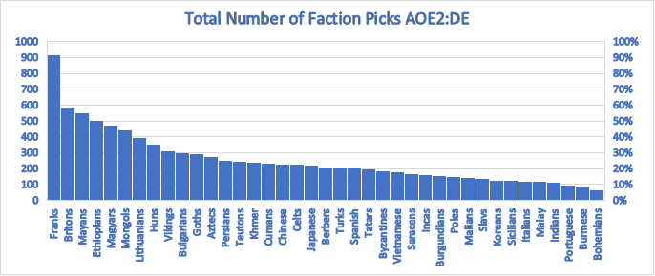

#### **Figure B)**

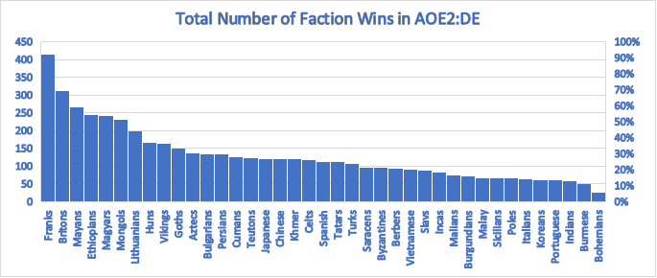

#### **Figure C)**

### **Questions From Chapter 2:**

* A player in AOE2 can choose one of several factions at the start of the match:
  + What are the odds that a player doesn’t pick the Mayans?
    - P(M) = 5.49108
    - P(1-M) = 1-5.49108% = .9450892
    - There is a 94.51% Chance that the player doesn’t pick the Mayans.
* What are the odds that Franks lose in a one-on-one game?
  + The Franks has a win rate of 45.2% so their lose rate would be (1-45.2)
    - (1-45.2) = 64.8%
  + A give person playing the Franks has a 64.8 percent chance of losing a given game.
* Suppose there is a 1/39 chance of playing against a Magyar pick, assuming outcomes are independent what are the odds of playing against the Magyars if two matches are played?
  + C (39, 2) = 741
* If 39 matches are played is there a 100% chance of encountering the Magyar? Why?
  + The chance of encountering the Magyars would not be 100% because every choice is independent and therefore a possibility exists where the Magyars are never encountered.
* The probability of the Teutonic Knights winning a match are 50.6% what are the odds they will win 4 independent games?
  + The Knights winning 4 independent games in a row is (.506^4) ≈ 6.555%
* In a population of Age of Empires 2 players, 40% prefer to play as factions that are classified as "rush" factions, while 60% prefer to play as factions that are classified as "boom" factions. It is reported that 50% of rush players and 70% of boom players win their one-on-one matches.
  + If a player is chosen at random from this population and is found to have won their one-on-one match, what is the conditional probability that this player played as a boom faction?
    - P(R) = 0.4 (the proportion of rush players in the population)
    - P(B) = 0.6 (the proportion of boom players in the population)
    - P(W|R) = 0.5 (the probability of winning a match given that the player is a rush player)
    - P(W|B) = 0.7 (the probability of winning a match given that the player is a boom player)
    - P(W) = P(W|R) * P(R) + P(W|B) * P(B)
    - P(B|W) = 0.7 * 0.6 / 0.58 ≈ 0.72
    - There is a 72% chance that the winner of the match will have played a boom faction.
* In a sample of 10 matches, what is the probability that all players will choose factions that belong to the same category (all "rush" factions or all "boom" factions)?
  + P(R) = 0.4 (the proportion of rush players in the population)
  + P(B) = 0.6 (the proportion of boom players in the population)
  + = 0.4^10 + 0.6^10
  + ≈ 0.604661764

### **Questions from Chapter 3:**

* In a sample of 100 matches, what is the probability distribution for the number of times that a particular faction is chosen?
  + C (100, k) * (1/31) ^ k * (38/39) ^(100-k)
* In a sample of 10,000, players select the "Mongols" civilization 441 times. Assuming each selection is independent and has a probability of being chosen of .0256, what is the probability that a player selects the "Mongols" civilization 3 times or more in a sample of 100 matches?
  + P (X >= 3) = 1-(P (X=0) + P (X=1) + P (X=2))
  + P (X ≥ 3) = 1 - (0.0495 + 0.1543 + 0.2241) ≈ 0.571
  + A player has an independent probability of .571 to choose the Mongols
* A player has a high win rate of .85 with as the Slavs. What is the probability of losing at least one match in the next 10 games played with this faction?
  + P (X = 0) = C (10, 0) * (0.15) ^ 0 * (0.85) ^ 10
    - => (1-0.017) => 0.983
  + The Slav player has a 98.3 percent chance of losing at least one match during his series.
* A player is trying to win match against their opponent by using a rush strategy. The probability of winning a match using this strategy is 0.2. What is the probability that the player will win their first match using this strategy on their 5th attempt?
  + P (winning on the 5th attempt) = (1 - 0.2) ^ (4) * 0.2 ≈ 0.0264
* Suppose there are 10000 players of Age of Empires 2, and 215 of them are experts who play the Portuguese and Malay. If a random sample of 100 players is chosen from the population of all players, what is the probability that exactly 10 of them use those specific factions?
  + P (X = 10) = (C (215, 10) * C (9785, 90)) / C (10000, 100)
    - The is a 4.02% chance that 10 pros will be chosen from those factions.
* A player is playing a series of one-on-one matches against their opponent. Based on experience, the player knows that they win an average of 2 match per hour. If the number of matches won by the player in an hour follows a Poisson distribution, what is the probability that the player will win exactly 5 matches in the next hour?
  + There is a probability of 0.03369, that a player will win 5 exactly 5 matches in the next hour.
* If the average time it takes to finish a match is 23 minutes find the percent of data that will fall within 1.4 deviations.
  + Using Chebyshev’s Theorem with an input of 1.4, the answer is that 48.98% of matches will fall within the deviations given.

# **Findings and Conclusions:**

## **Disclaimer**

* + There are various anomalies when observing the relation between pick-rates and win rates of different factions in 1v1 situations. Initially the most interesting thing uncovered was that just because a faction is picked more often than others, doesn’t mean that it has a higher on average win rate, in fact quite the opposite is true. When looking at factions with the most players, such as the Franks of the Mayans, it is easy to see that they have a bellow average win rate. The logical explanation to this is that they are factions that new players are more likely to pick and subsequently lose as, as my data doesn’t consider ELO. Another large hole in my data and outcomes are that I don’t consider the opponent’s faction. Initially I had figured that its matchups wouldn’t have a huge effect with a large enough dataset, and while it may not with a much larger set, 10,000 points spread across 39 factions is not enough to rule it out. Outliers such as the Portuguese Players may have got lucky with their matchups in order to achieve the highest average, or it could just be that the best players know something everyone else doesn’t and so they pick the Portuguese or Slavs or other factions with a higher win rate.

## **Final Thoughts**

* + Although the data is ultimately incomplete, that doesn’t mean that there is nothing useful to be derived from the data. For instance, looking at the win rates alone, you can make assumptions about Civilizations with more counters than others, for instance, the Franks and Bohemians may have more hard counters than other factions leading to them being disadvantaged throughout the game. To answer my initial questions, based on the information gathered here, I have concluded that although unpopular the Portuguese are the best faction for 1v1 matchups, as they have the highest win rate of any faction coming in at 64.2%. Although while playing it may not feel this way based on data most factions have a balanced win rate clustering around 50%. Based on that Age of Empires 2: DE for the most part is a mostly balanced game for one-on-ones.